
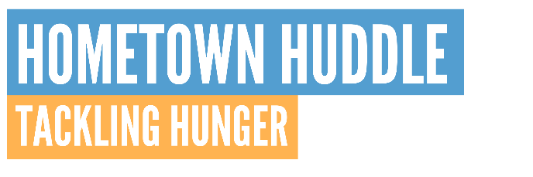
Team,
We will be participating in United Way’s Hometown Huddle. The theme this year is tackling hunger. One in six children live in a food-insecure household. School breaks should not mean hungry children in our community. Become a real MVP by participating in the Hometown Huddle food drive for children in our community.
If you are able to contribute, the United Way has provided two easy ways to participate this year.
- Bring your donated food items from the list below to INSERT WHERE YOU ARE COLLECTING SUPPLIES EX- BREAKROOM by INSERT DATE.

- Purchase food items on United Way’s Amazon Wishlist. The items will be shipped directly to United Way’s office. Click here to view the Amazon Wishlist.

Hometown Huddle List of Acceptable Foods
All items must be single servings and should not require refrigeration.

Cereal/oatmeal - single serve packs
Hormel Compleats
Fruit snacks
Granola bars
Juice Boxes
Microwavable mac and cheese
Peanut butter
Reusable water bottles
Rice Krispy Treats / other individually packaged treats
Individual Pop Tarts packs
Jello and pudding cups
Microwavable single serve soup
Tuna/Chicken packets

Change doesn’t happen alone. Join us and help eliminate childhood hunger in our community.
For more information on United Way’s Hometown Huddle, visit yourlocaluw.org/hometownhuddle.
Thank you!

